Year 8 Science
Physical Sciences
Revision (Answers)

Heat Transfer (See Ch. 10.2 of textbook)

1. 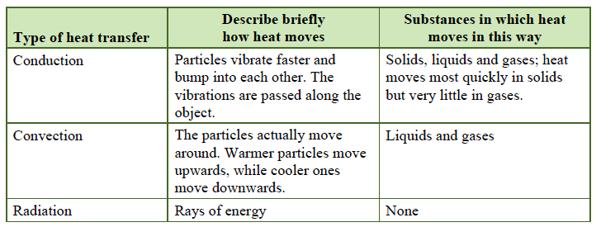

2. An insulator is a substance that is a poor conductor of heat. Glass, wood, rubber and plastic can act as insulators.

3. Radiation.

4. Radiated heat can be transmitted, absorbed or reflected.

5. The particles in liquids and gases are further apart than those in solids, so the vibrations are not passed along as quickly.

Sound Energy (See Ch. 10.5 of textbook)

1. Vibrations causing the movement of air particles to create a series of compressions and rarefactions.

2. Air particles in a silent room are relatively evenly spaced. Air particles in compressions are closer together and in rarefactions they are further apart than in a silent room.

3. In empty space, there are no particles. For a sound to be produced, there needs to be particles that can vibrate.

4. Make the straw shorter. When lightning and thunder occur during an electrical storm, we see the lightning before we hear the thunder. When a fighter jet flies overhead, you can see it before you hear it.

5. A short string.

6. The sound wave can be transmitted, reflected or absorbed.

7. Hard surfaces, such as bathroom tiles, cause reverberation.

